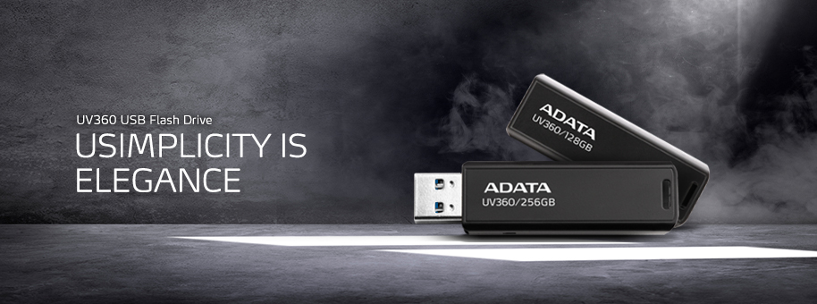

UV360 USB Flash Drive
The UV360 USB flash drive does away with misplaced caps. It comes with up to 256GB of capacity and supports USB 3.2 Gen 1 for speedy transfers of movies, music, photos, and more.
Classic Elegance  With a beautiful matte finish, the UV360 exudes a sense of understated elegance and sophistication.  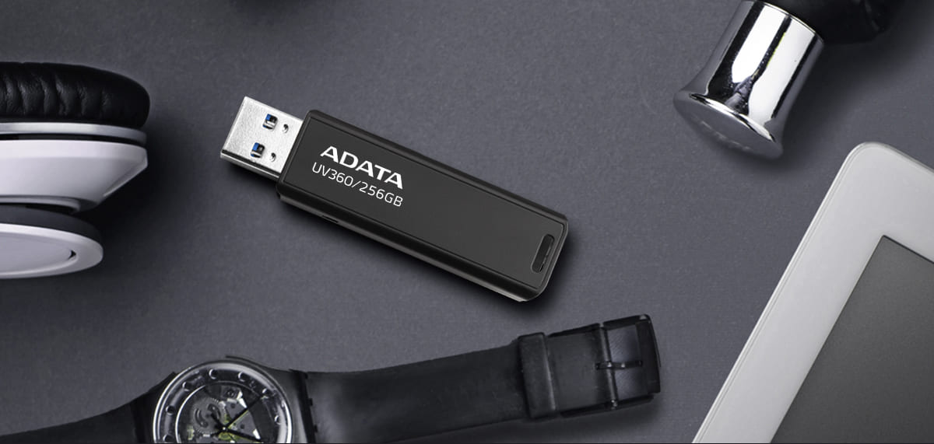 | No More Lost Caps  A slide of your thumb is all you need to access the connector. Slide it back in when your done. Simple!  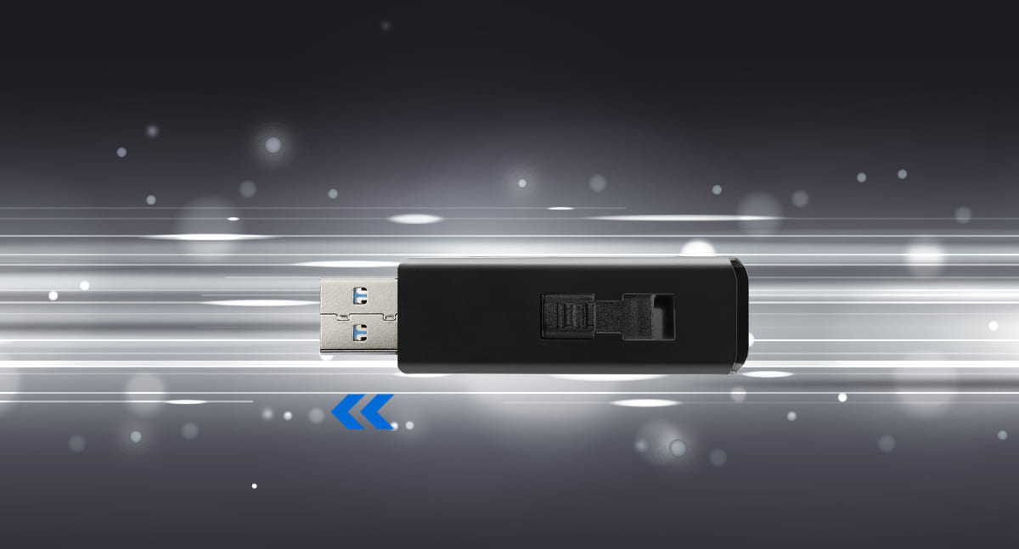

Lots of Space  Whether you're carrying around 4K movies, photo albums, or work files, the UV360 has you covered with up to 256GB of storage capacity.  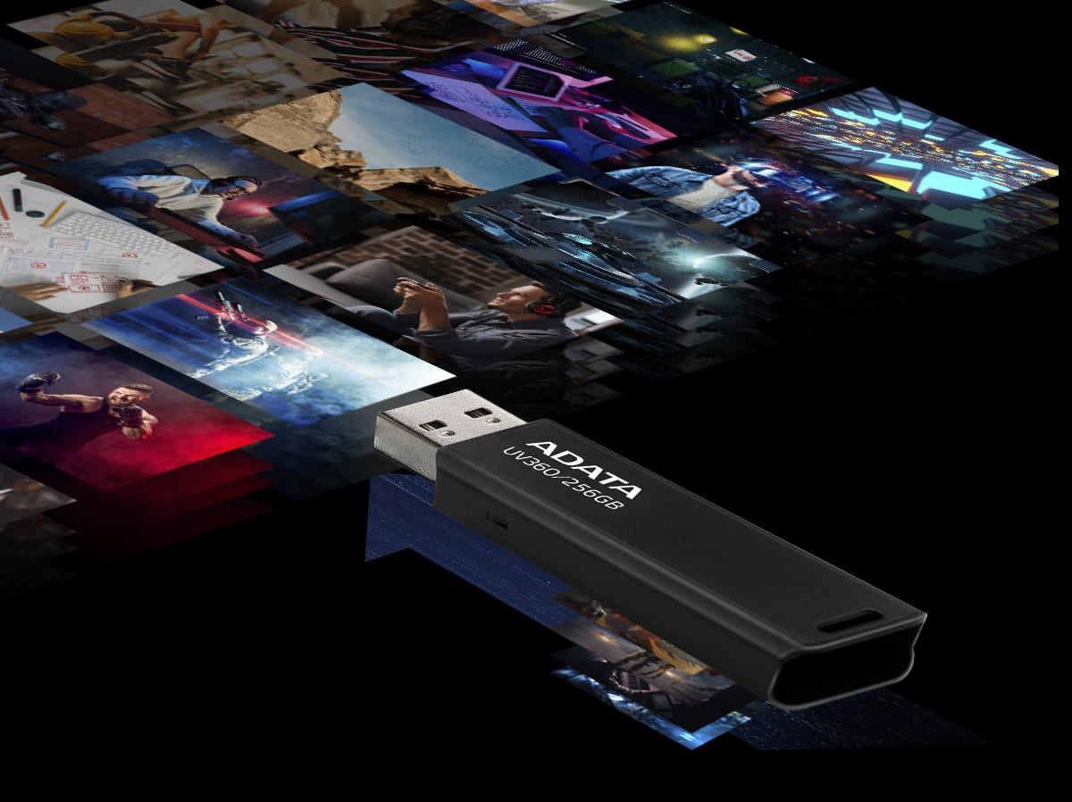  Features  ● Convenient capless design  ● Diverse capacities: 32GB to 256GB  ● Includes a strap hole to attach to lanyard or keychain  ● High compatibility: PCs, tablets, smart TVs, in-car  systems, game consoles, home entertainment systems and more  Specifications  ● Capacity: 32GB / 64GB / 128GB / 256GB  ● Color: Black  ● Dimensions (L x W x H):  53.3 x 17.9 x 7.4mm / 2.1 x 0.7 x 0.3”  ● Weight: 13.9g / 0.5oz  ● Interface: USB 3.2 Gen1  ( backward compatible with USB 2.0 )  ● System requirements:  Windows XP, Vista, 7, 8, 8.1, 10,  Mac OS X 10.6 or later, Linux kernel 2.6 or later, with no device driver needed  ● Warranty: 5-year limited | Convenient Lanyard Hole  The UV360 has a lanyard hole for attaching to lanyards and keychains for easy carrying.  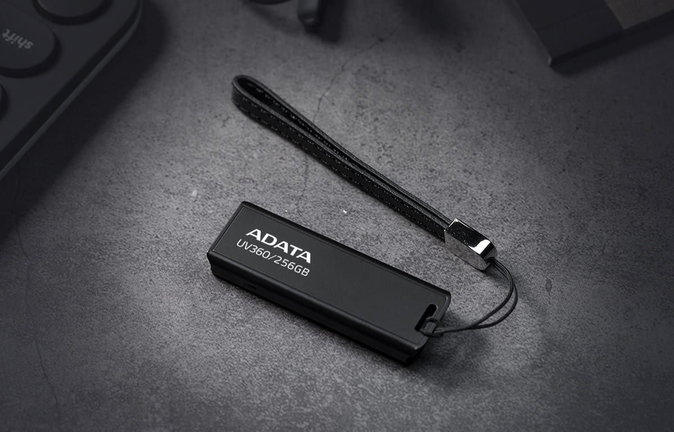  Ordering Information  Capacity Color Product Code EAN Code  32GB Black AUV360-32G-RBK 4710273777740  64GB Black AUV360-64G-RBK 4710273777757  128GB Black AUV360-128G-RBK 4710273777733  256GB Black AUV360-256G-RBK 4710273777931

